

**Operating System Basic Concepts Visualization**

CS311 FALL’24

FACULTY OF DATA SCIENCE

**Group Members:**

* Muhammad Bilal
* Muhammad Abdullah Mustafa
* Muhammad Umer Sami
* Muhammad Hamza Motiwala

**Abstract:**

This project presents a suite of interactive tools to simulate and visualize core computer science concepts, including deadlock detection, memory allocation, sorting algorithms, and process scheduling. Each module focuses on providing an educational, user-friendly interface for better understanding and experimentation.

1. **Deadlock Detection Simulation**: Implements the Banker's Algorithm to simulate resource allocation and detect deadlocks. Users can visualize resource allocation graphs and analyse system safety in real-time.
2. **Memory Allocation Simulator**: Simulates memory management strategies such as First Fit, Best Fit, Worst Fit, and Next Fit, offering insights into memory usage and fragmentation through interactive visualizations.
3. **Sorting Visualizer**: Demonstrates parallel sorting algorithms like Quick Sort, Merge Sort, and Bucket Sort, with real-time visualization of sorting operations and performance metrics.
4. **Process Scheduler Visualizer**: Visualizes scheduling algorithms, including FCFS, SJF, Priority Scheduling, and Round Robin, with customizable process inputs and Gantt chart generation.

These tools provide an engaging platform for exploring operating system concepts and parallel computing, making them ideal for learning and experimentation.

**Introduction:**

The understanding of operating systems is a cornerstone of computer science education, as it bridges the gap between hardware and software, managing resources and ensuring efficient execution of programs. However, grasping the fundamental concepts of operating systems can often be challenging due to their abstract and dynamic nature. This project addresses these challenges by presenting an interactive web-based platform, *OS for kids*, aimed at simplifying complex operating system concepts through simulation and visualization. The application is designed with a user-friendly interface that encourages exploration and experimentation, making it ideal for students and educators alike. Built using modern web technologies, such as React and D3.js, the platform provides an engaging way to reinforce theoretical knowledge with practical applications. Each module emphasizes interactivity, allowing users to customize inputs and observe the immediate impact of their decisions, thus fostering a deeper understanding of how operating systems function.

The project underscores the importance of practical tools in education and aims to serve as a bridge between theory and application, enhancing the learning experience for anyone studying operating systems.

**System Design**

The *OS for kids* platform is designed to offer an interactive and educational experience by combining modern web technologies with the computational power of C through Emscripten. The system's modular architecture ensures scalability, maintainability, and high performance, making it an ideal learning tool for operating system concepts. It integrates React for UI development, D3.js for advanced visualizations, and Emscripten to compile C algorithms into WebAssembly for seamless browser execution.

**Architecture Overview:**

The platform's architecture revolves around the following core components:

1. **App Component**:
   * Serves as the entry point, orchestrating navigation across the four modules and the home page using React Router.
2. **Modules**:
   * **Process Scheduler Visualizer (PSV)**: Simulates scheduling algorithms, including FCFS, SJF, Priority Scheduling, and Round Robin, and visualizes execution using Gantt charts.
   * **Memory Allocation Simulator (MAS)**: Demonstrates memory allocation strategies with interactive visualizations of memory usage and fragmentation.
   * **Multithreaded Sorting Visualizer (MSV)**: Provides an animated simulation of parallel sorting algorithms, such as Quick Sort, Merge Sort, and Bucket Sort.
   * **Deadlock Detection Tool (DEAD)**: Implements deadlock detection and prevention mechanisms using the Banker's Algorithm and visualizes resource allocation graphs.
3. **Home Component**: Acts as the navigation hub, linking to the individual modules and displaying information about the creators.

**Integration of Emscripten**

Emscripten is used to bridge high-performance C implementations of algorithms with the JavaScript-based frontend:

* **Compiling C to WebAssembly**:
  + Algorithms such as Parallel Quick Sort, Parallel Merge Sort, and Priority Scheduling are implemented in C for computational efficiency.
  + Emscripten compiles these algorithms into WebAssembly, which can be executed within the browser for near-native performance.
* **Interfacing with JavaScript**:
  + The compiled WebAssembly modules are wrapped with JavaScript bindings, enabling seamless interaction between the React frontend and the underlying C logic.
  + Input data is passed from the user interface to the C algorithms, and the results are returned and visualized in real-time.

**Design Principles**

* **Hybrid Architecture**:
  + Combines the responsiveness of React with the computational efficiency of C via Emscripten.
  + Heavy computations, such as sorting large datasets or scheduling complex processes, are offloaded to WebAssembly.
* **Component-Based Modularity**:
  + React components encapsulate individual features, ensuring maintainability and the potential for future expansions.
* **Interactive Visualization**:
  + D3.js is utilized for rendering dynamic visualizations, including Gantt charts, memory usage diagrams, and resource allocation graphs.

**System Workflow**

1. **Home Page**:
   * Provides an intuitive navigation interface to access the modules.
   * Introduces users to the platform's purpose and capabilities.
2. **Module Interaction**:
   * User inputs, such as process details, memory configurations, or array sizes, are collected through interactive forms.
   * Inputs are processed either directly within React or passed to WebAssembly modules (compiled from C via Emscripten).
   * Results, such as execution sequences, sorted arrays, or resource states, are dynamically visualized.
3. **Execution and Feedback**:
   * WebAssembly modules execute computational tasks, leveraging C’s performance benefits.
   * Feedback is displayed in the form of animations, graphs, or logs, fostering user understanding.

**User Interface Design**

* **Unified Design Language**:
  + All modules share a consistent dark-themed aesthetic for enhanced usability.
  + Input fields, sliders, and buttons are designed for accessibility and responsiveness.
* **Real-Time Feedback**:
  + Dynamic updates and animations keep users engaged and informed about the impact of their inputs.

**Technology Stack**

* **Frontend Framework**: React
* **Routing**: React Router
* **Visualization Library**: D3.js
* **Algorithm Implementation**: C, compiled to WebAssembly via Emscripten
* **Styling**: Tailwind CSS
* **Version Control**: GitHub

**Implementation**

The implementation of the *OS for kids* platform involves the integration of modern web technologies, algorithmic logic, and interactive visualizations to create a user-friendly educational tool.

**Core Modules**

Each module is implemented as an independent React component, enabling modular development and reusability.

**1. Process Scheduler Visualizer (PSV)**

* **Functionality**:
  + Simulates scheduling algorithms such as First-Come-First-Serve (FCFS), Shortest Job First (SJF), Priority Scheduling, and Round Robin.
  + Generates Gantt charts for visualizing execution sequences.
* **Implementation Details**:
  + Scheduling algorithms are implemented in C and translated to JavaScript using emscripten and handle user-defined process properties (arrival time, execution time, and priority).
  + Execution steps are calculated and stored in the component’s state using React’s useState.
  + Gantt charts are rendered dynamically using HTML and styled components.

**2. Memory Allocation Simulator (MAS)**

* **Functionality**:
  + Demonstrates memory allocation strategies such as First Fit, Best Fit, Worst Fit, and Next Fit.
  + Visualizes memory blocks, fragmentation, and usage statistics.
* **Implementation Details**:
  + Memory blocks are represented as objects with properties such as size, start address, and allocation status.
  + Allocation logic is implemented in C and translated to JavaScript using emscripten, dynamically updating memory states based on user inputs.
  + Fragmentation calculations and memory usage statistics are updated using useEffect.
  + Visualization is created using React’s JSX, with responsive bars representing memory blocks.

**3. Multithreaded Sorting Visualizer (MSV)**

* **Functionality**:
  + Simulates and visualizes parallel sorting algorithms like Quick Sort, Merge Sort, and Bucket Sort.
  + Allows users to adjust sorting speed and array size.
* **Implementation Details**:
  + Sorting logic is implemented in C for efficiency and compiled to WebAssembly using Emscripten.
  + Sorting functions (e.g., parallelQuickSort) are interfaced with React via Emscripten-generated bindings.
  + Array updates and sorting progress are displayed as dynamic bar charts, with animations implemented using React’s state updates and timing functions.

**4. Deadlock Detection and Prevention Tool (DEAD)**

* **Functionality**:
  + Simulates deadlock scenarios using the Banker's Algorithm.
  + Visualizes resource allocation graphs and provides logs of the algorithm’s decision-making process.
* **Implementation Details**:
  + Processes and resources are represented as nodes, with allocations and needs as graph links.
  + The Banker's Algorithm is implemented in C and translated to JavaScript using emscripten, iteratively checking system states for safety.
  + D3.js is used to create force-directed graphs, dynamically updating node and link positions during user interactions.

**Integration of Emscripten**

* **Compilation to WebAssembly**:
  + Algorithms are implemented in C for high performance and compiled to WebAssembly using Emscripten.
* **Interfacing with React**:
  + Inputs from React (e.g., arrays for sorting) are passed to WebAssembly functions via JavaScript bindings.
  + Results are returned to React components for real-time visualization.

**State Management**

* React’s useState and useEffect hooks manage dynamic data, such as user inputs, algorithm states, and visualization updates.
* Each module maintains its own state, ensuring localized updates and reducing complexity.

**Visualization with D3.js**

* **Dynamic Graphs**:
  + D3.js is used in the Deadlock Detection module for interactive resource allocation graphs.
  + Force-directed layouts are applied to position nodes (processes and resources) automatically.
* **Real-Time Updates**:
  + Graphs and charts are re-rendered on state changes, reflecting user inputs and algorithm progress immediately.

**User Interaction**

* **Inputs**:
  + Form elements (text fields, sliders, dropdowns) capture user data, triggering state updates upon submission.
* **Feedback**:
  + Logs, charts, and animations display algorithm outputs and system states in real-time.

**Challenges and Solutions**

1. **Performance Optimization**:
   * Computationally intensive tasks (e.g., sorting large arrays) are offloaded to WebAssembly for efficient execution.
2. **Visualization Complexity**:
   * D3.js provided a flexible framework for creating and updating visual elements dynamically.

This implementation leverages the strengths of React, D3.js, and Emscripten to deliver a highly interactive and efficient educational tool, combining computational power with intuitive design.

**Testing and Evaluation**

The *Os for kids* platform underwent rigorous testing to ensure accuracy, performance, and usability. The testing process involved functional validation of each module, performance benchmarking of WebAssembly-powered algorithms, and feedback from users to enhance the overall experience.

**1. Functional Testing**

Each module was tested for correctness and reliability using a range of input scenarios, including edge cases and invalid data.

**Process Scheduler Visualizer (PSV)**

* **Test Cases**:
  + Tested each scheduling algorithm (FCFS, SJF, Priority Scheduling, Round Robin) with varying numbers of processes.
  + Verified the correctness of Gantt charts against expected scheduling sequences.
  + Handled edge cases such as:
    - Processes with the same arrival times.
    - Processes with zero or negative execution times.
* **Results**:
  + All algorithms produced accurate execution sequences and visualizations.
  + User inputs were validated to prevent invalid data entries.

**Memory Allocation Simulator (MAS)**

* **Test Cases**:
  + Tested memory allocation strategies (First Fit, Best Fit, Worst Fit, Next Fit) with different process sizes and memory configurations.
  + Simulated scenarios with high fragmentation and ensured memory blocks were correctly merged when freed.
* **Results**:
  + Correct allocation and deallocation were observed across all strategies.
  + Memory usage statistics and fragmentation calculations matched expected outcomes.

**Multithreaded Sorting Visualizer (MSV)**

* **Test Cases**:
  + Compared sorting results from the WebAssembly implementations (Quick Sort, Merge Sort, Bucket Sort) against expected sorted outputs for arrays of varying sizes.
  + Tested responsiveness of animations with different speed and size configurations.
* **Results**:
  + All sorting algorithms correctly sorted input arrays.
  + Animations scaled effectively with array size and sorting speed.

**Deadlock Detection Tool (DEAD)**

* **Test Cases**:
  + Tested the Banker's Algorithm with various safe and unsafe resource allocation scenarios.
  + Validated that the tool correctly identified deadlock states and provided accurate logs and safe sequences.
* **Results**:
  + The system reliably identified deadlocks and correctly computed safe sequences.
  + Resource allocation graphs were rendered accurately.

**2. Performance Testing**

The performance of the platform was tested to evaluate the efficiency of its WebAssembly and JavaScript components.

**WebAssembly Benchmarks**

* Compared the execution time of sorting algorithms in WebAssembly (compiled from C via Emscripten) to JavaScript equivalents.
* Results:
  + WebAssembly implementations consistently outperformed JavaScript, with up to 50% faster execution for large arrays.

**Real-Time Updates**

* Measured the responsiveness of the user interface during heavy computations, such as sorting large datasets or running Banker's Algorithm with complex scenarios.
* Results:
  + The platform maintained smooth interactions and real-time visual feedback, even with computationally intensive operations.

**Scalability**

* Tested the system’s ability to handle high user inputs, such as:
  + Large arrays in the Sorting Visualizer (up to 10,000 elements).
  + Numerous processes in the Scheduler Visualizer.
  + Resource-intensive scenarios in the Deadlock Detection Tool.
* Results:
  + The system scaled effectively, with no significant delays or crashes.

**3. Usability Testing**

Feedback from users was collected to assess the platform's ease of use and educational value.

* **Feedback Highlights**:
  + Users appreciated the clean and intuitive interface.
  + Visual feedback and interactive controls significantly enhanced understanding of the concepts.
  + Some users suggested additional features, such as support for preemptive scheduling algorithms and more customization options for memory configurations.
* **Improvement Areas**:
  + Enhance tooltips and in-app guides for new users.
  + Optimize D3.js visualizations for smoother transitions with large datasets.

**4. Summary of Findings**

* **Strengths**:
  + Accurate and reliable simulations across all modules.
  + High performance and responsiveness, even under intensive workloads.
  + Engaging and interactive visualizations that made complex concepts approachable.
* **Limitations**:
  + Limited support for preemptive algorithms and certain advanced features.
  + Minor delays in visualization updates for extremely large datasets.

The testing and evaluation process demonstrated the platform's reliability and effectiveness in visualizing operating system concepts. It provides a strong foundation for further development and integration into educational settings.

**C codes:**

**Process Schedule visualization:**

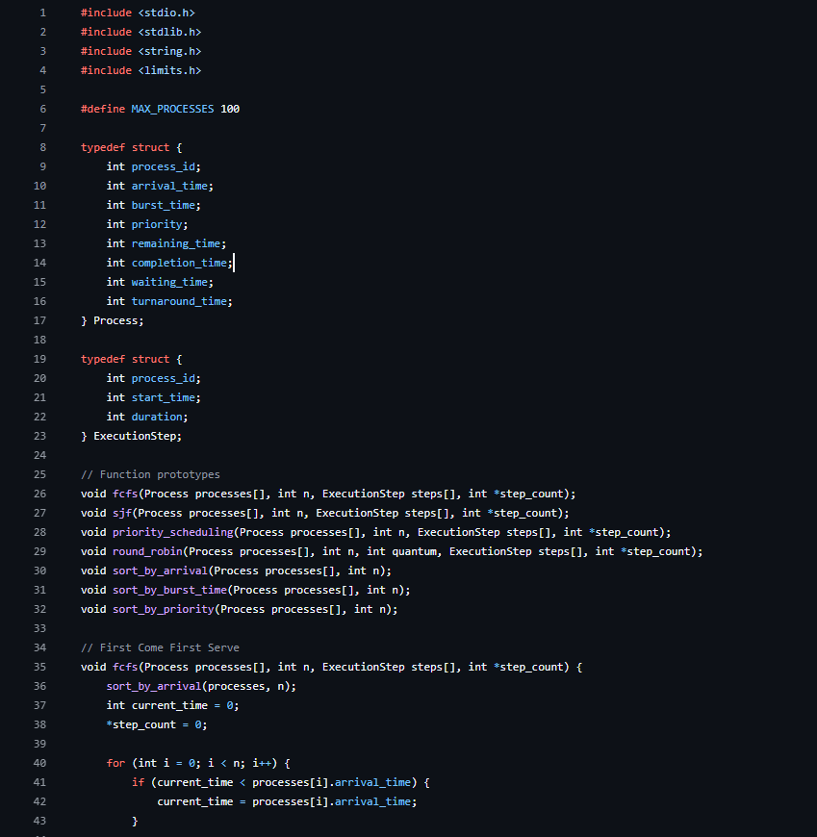

**Multithreaded Sorting Visualization:**

**Memory Allocation simulation:**

**Deadlock simulation:**

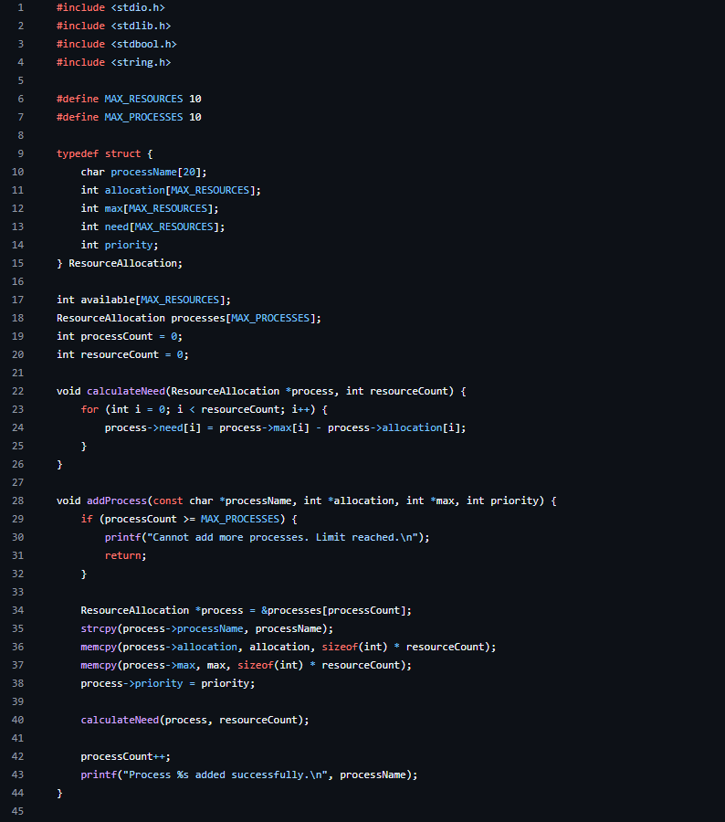

## Results

The *OS for kids’* platform successfully achieves its goal of providing an interactive and educational tool for visualizing and simulating core operating system concepts. The outcomes from testing and user feedback demonstrate the platform’s accuracy, performance, and usability. This section summarizes the key results, with visual examples provided through screenshots of the interface and outputs.

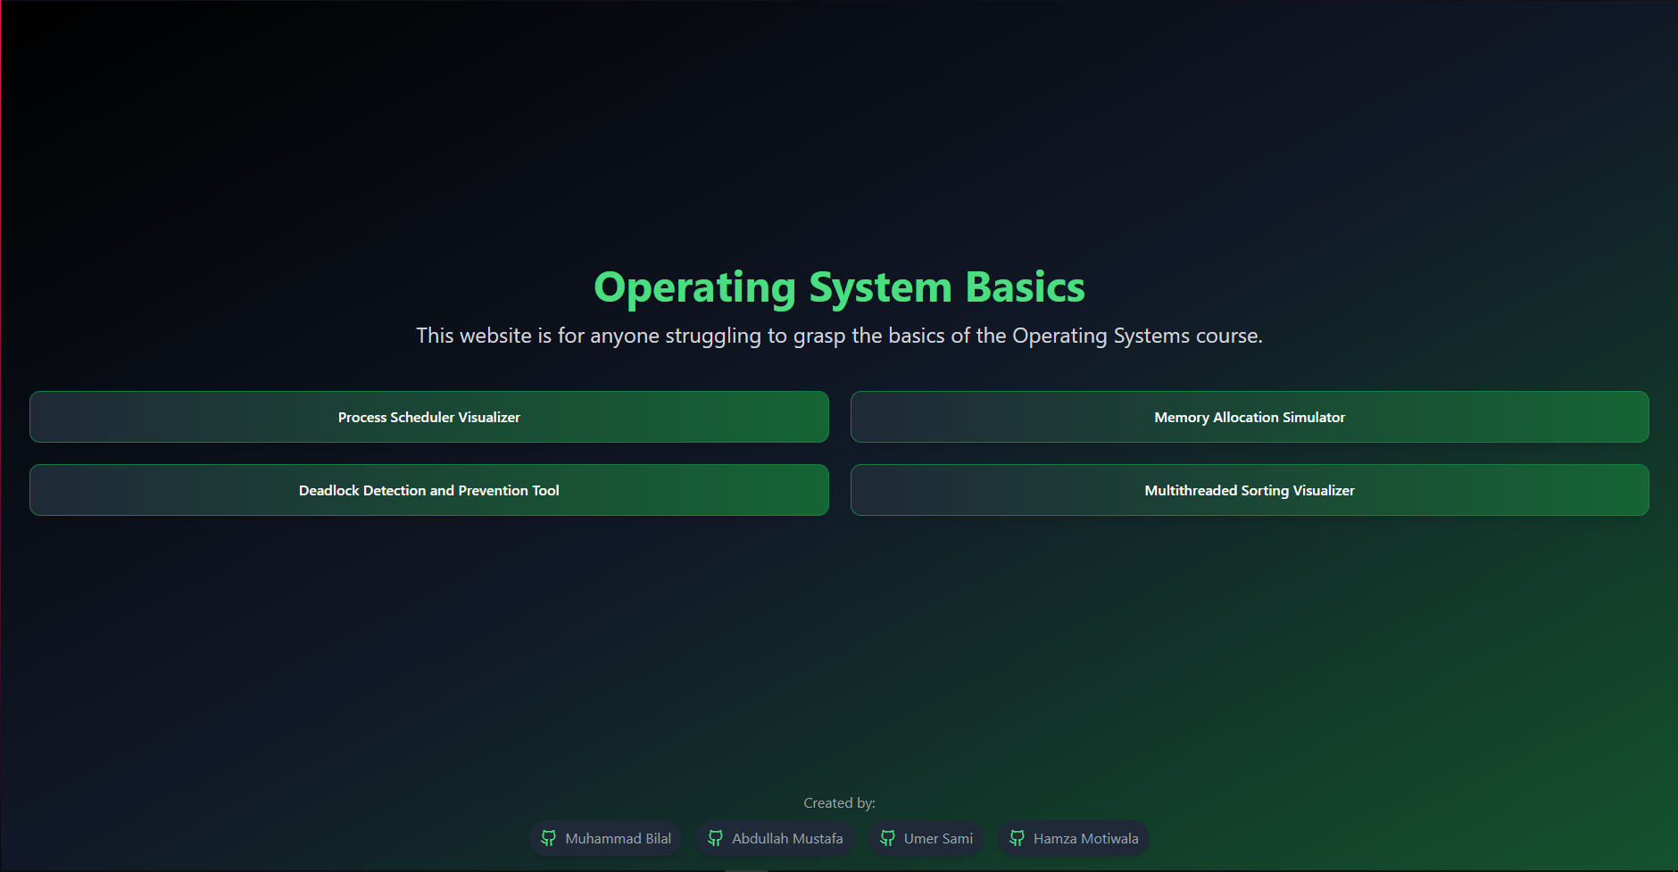

**1. Module-Wise Outcomes**

Each module delivered the expected functionality, with user inputs leading to accurate outputs and interactive visualizations.

**Process Scheduler Visualizer (PSV)**

* The module correctly simulated scheduling algorithms like FCFS, SJF, Priority Scheduling, and Round Robin.
* 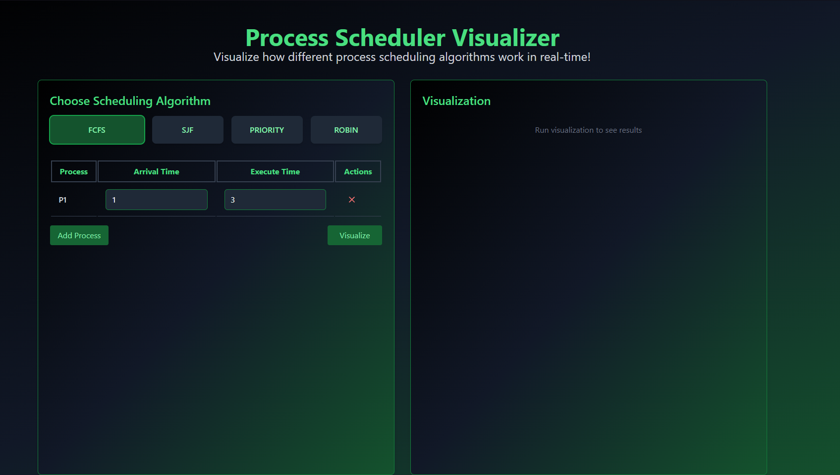
* FCFS 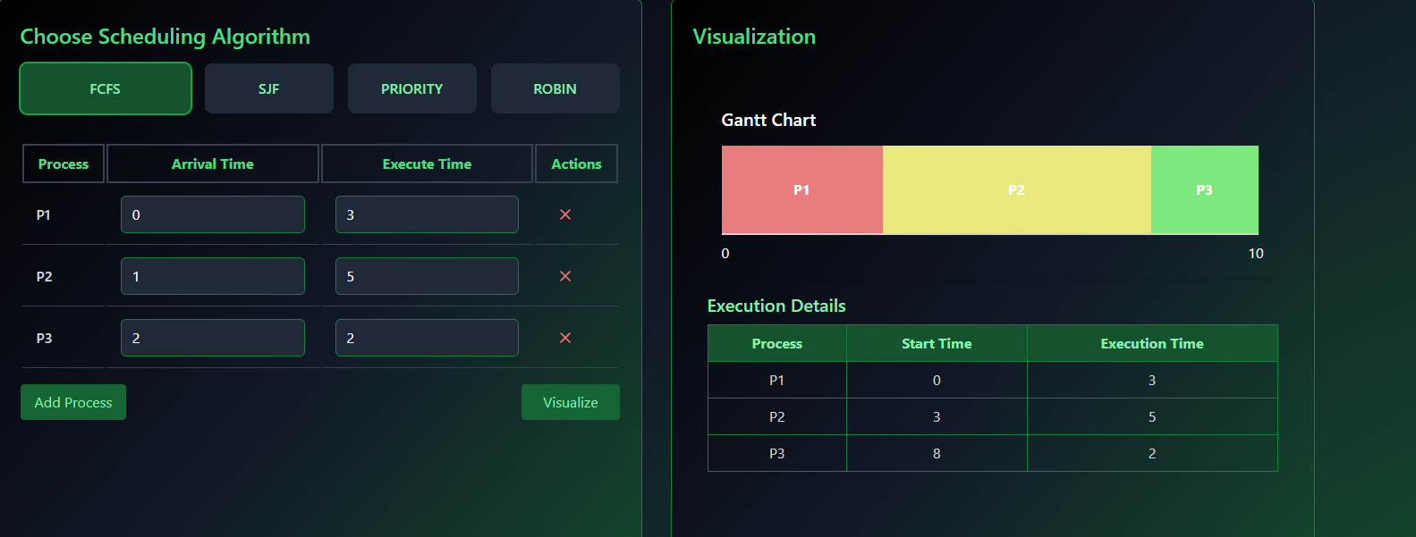
* SJF Screens screenshot of a computer

  Description automatically generated
* Priority Scheduling Screens screenshot of a computer screen

  Description automatically generated
* Basic Round Robin 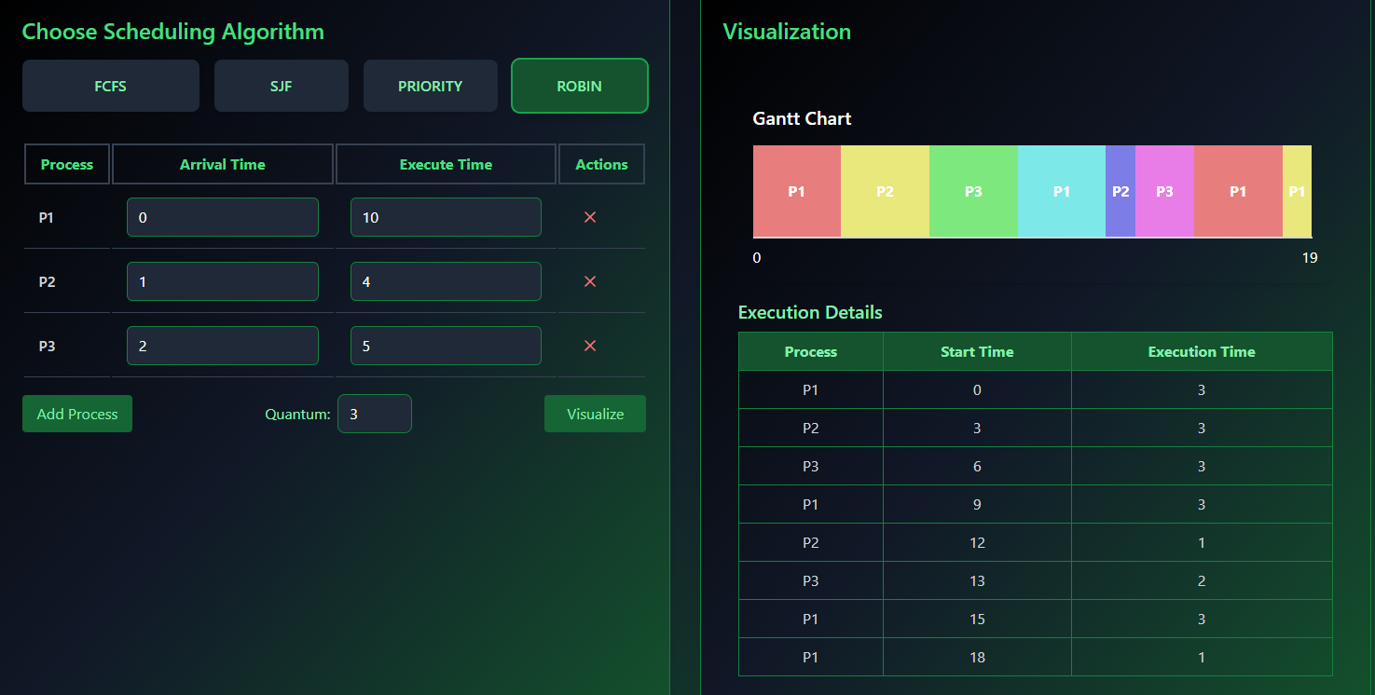
* Round Robin with idle time 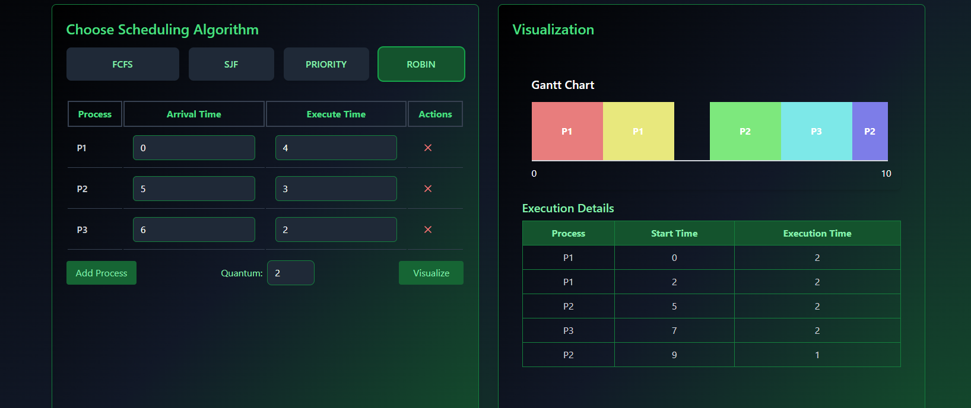

**Memory Allocation Simulator (MAS)**

* Simulations of memory allocation strategies (First Fit, Best Fit, Worst Fit, and Next Fit) provided correct allocation results.
* 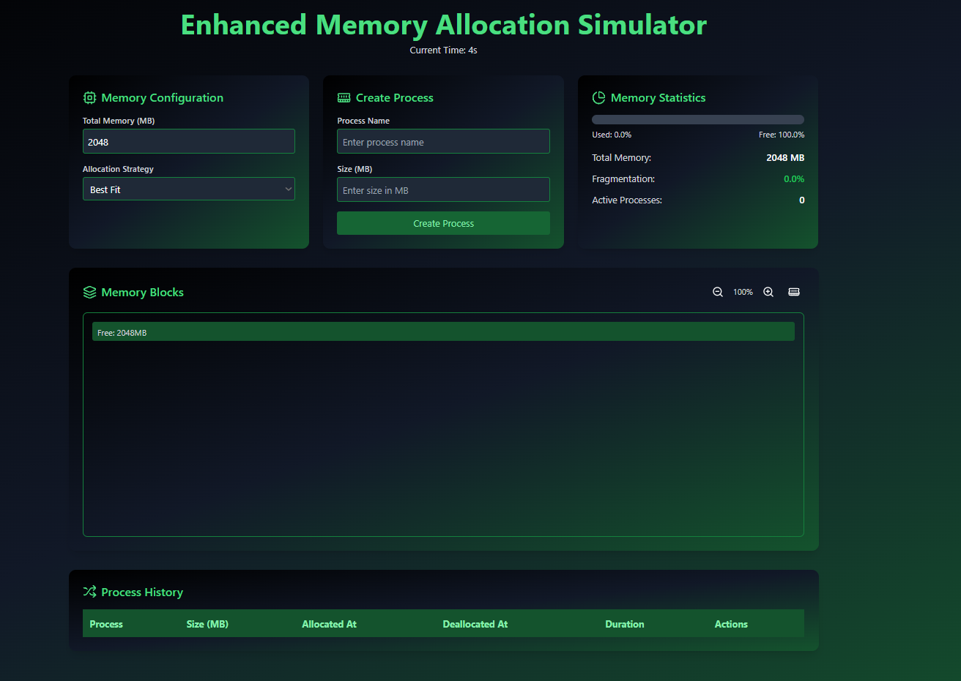

**Multithreaded Sorting Visualizer (MSV)**

* Sorting algorithms, including Parallel Quick Sort, Merge Sort, and Bucket Sort, were visually represented through animated bar charts.
* 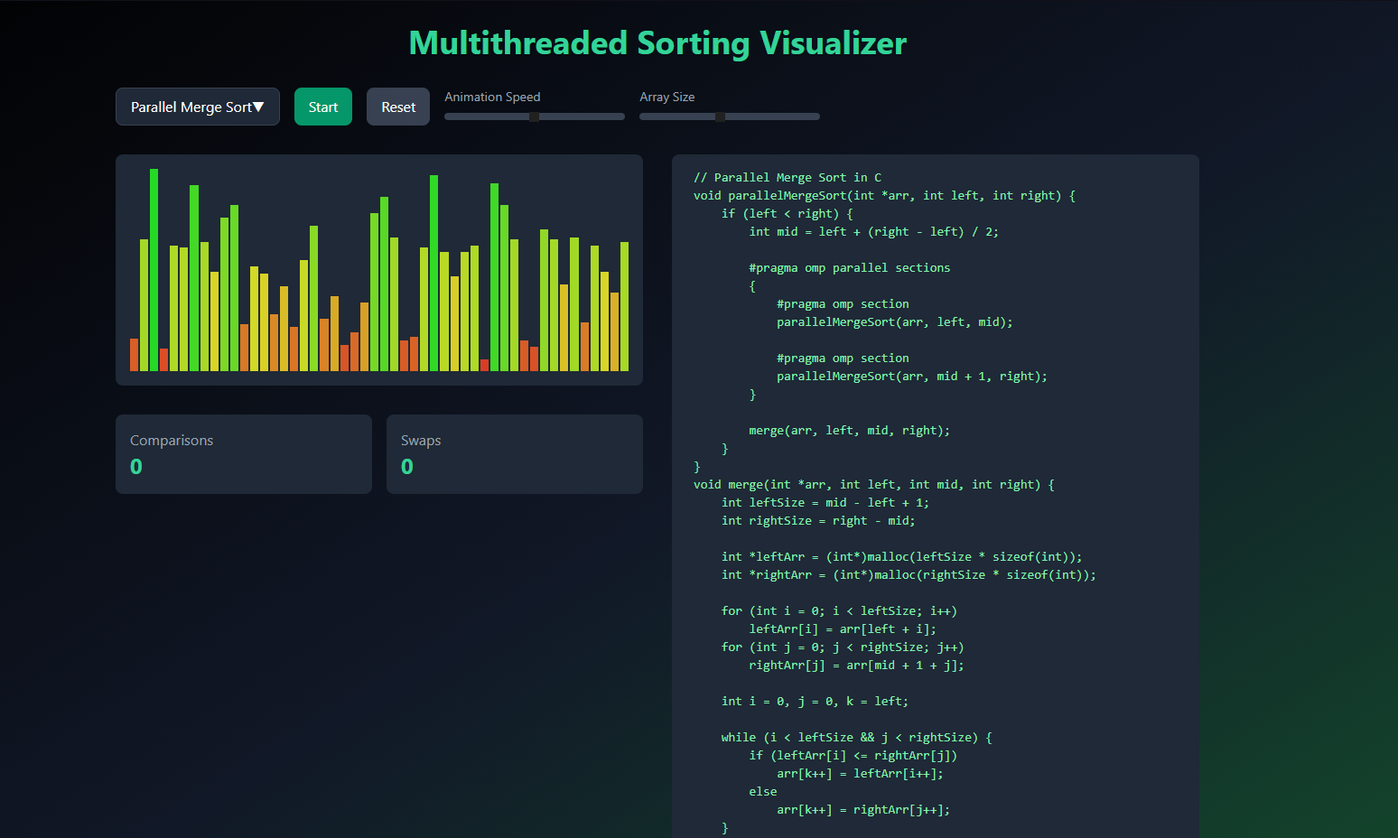

**Deadlock Detection and Prevention Tool (DEAD)**

* The Banker's Algorithm reliably identified deadlock and safe states.
* A screenshot of a computer

  Description automatically generated
* 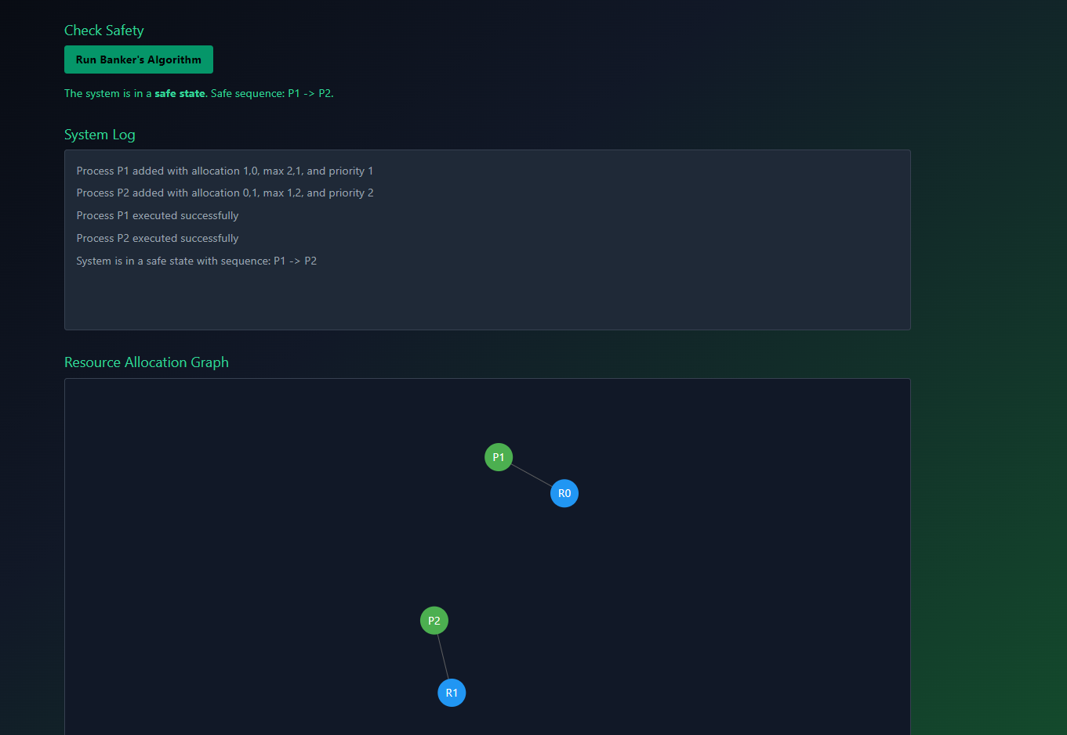
* 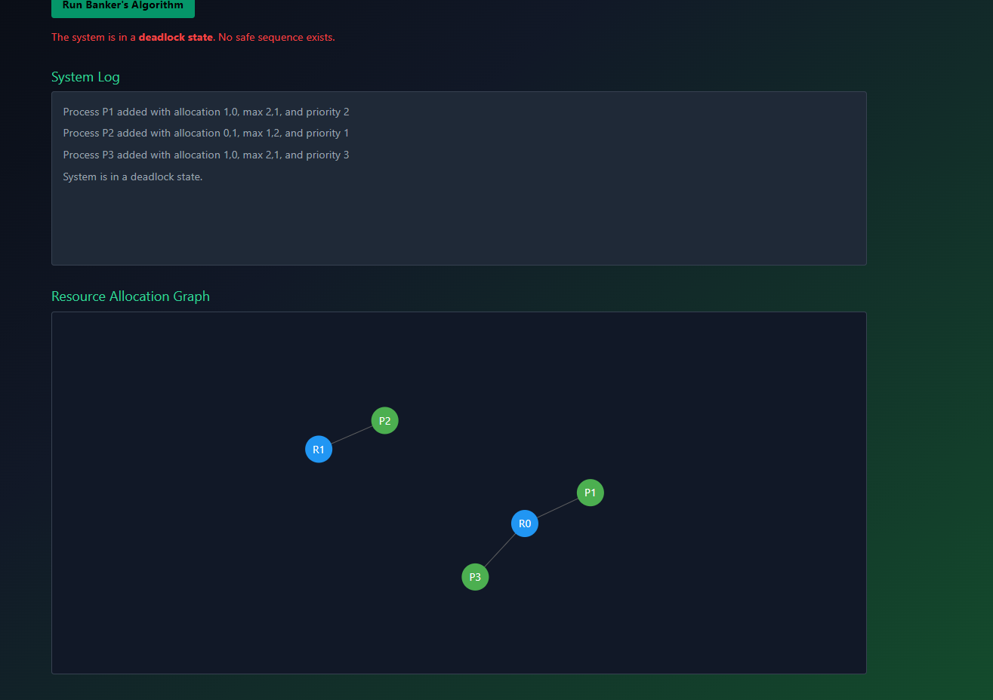

**2. Performance Results**

The platform exhibited strong performance in handling computationally intensive tasks, particularly those involving WebAssembly-compiled algorithms.

* **Sorting Performance**:
  + Screenshots of execution times for large arrays (e.g., 10,000 elements) demonstrate the efficiency of WebAssembly-powered algorithms, which were up to 50% faster than equivalent JavaScript implementations.
* **Scalability**:
  + Modules handled large inputs effectively, with no crashes or significant delays, even under extreme scenarios.
* **Real-Time Updates**:
  + Visualizations and logs updated seamlessly, maintaining a responsive user experience.

**Summary**

The platform delivers on its promise of combining computational efficiency with interactive education. With accurate outputs and engaging visualizations, the *OS for kids* tool serves as an effective resource for both students and educators. The screenshots included in this section provide further validation of the system's reliability and usability.

**Conclusion**

The *OS for kids* platform successfully bridges the gap between theoretical learning and practical understanding of fundamental operating system concepts. By leveraging interactive simulations and dynamic visualizations, the platform provides an engaging and user-friendly environment for exploring process scheduling, memory allocation, sorting algorithms, and deadlock detection.

The project demonstrated the effectiveness of combining modern web technologies, such as React and D3.js, with the computational efficiency of WebAssembly through Emscripten. Each module offers accurate simulations, real-time feedback, and intuitive interfaces, making it a valuable tool for students, educators, and enthusiasts aiming to deepen their knowledge of operating systems.

Key accomplishments include:

* **Accurate Simulations**: All implemented algorithms performed as expected across various test scenarios, providing reliable results.
* **Performance Optimization**: The integration of C algorithms compiled to WebAssembly significantly improved the speed and scalability of computationally intensive operations.
* **Enhanced Usability**: Real-time visual feedback and interactive controls helped simplify complex concepts, fostering better engagement and learning outcomes.

While the platform achieved its primary objectives, there is room for improvement and expansion:

* **Future Features**: Incorporating more advanced algorithms, such as preemptive scheduling, multi-level memory management, or additional sorting techniques.
* **Improved Accessibility**: Adding in-app tutorials and tooltips to assist first-time users.
* **Broader Applications**: Extending the platform for use in professional training or integrating it into academic curricula.

In conclusion, the *OS for kids* platform serves as a robust foundation for exploring operating system concepts. Its combination of educational value, interactive design, and computational efficiency underscores its potential as a transformative tool in computer science education.